LAB EXPERIMENTS

NAME : V VISHWA

REG NO : 192421374

SUBJECT: CSA1423 COMPILER DESIGN

# Experiment 6 – Extend the Lexical Analyzer to Check Comments

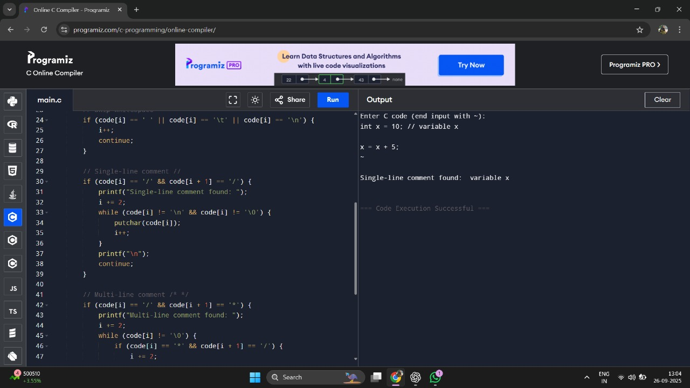

# Experiment 7 – Lexical Analyzer for Identifiers, Constants, Operators

